Veteran Readiness and Employment e-Invoicing User Guide
How to Create an Invoice

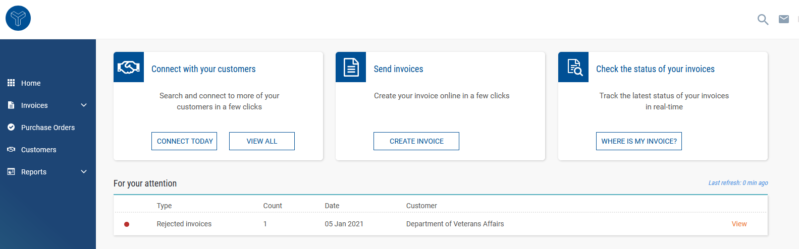
Step 1 – Navigate to Purchase Orders Page

Step 2 – Find Your PO/Authorization Number
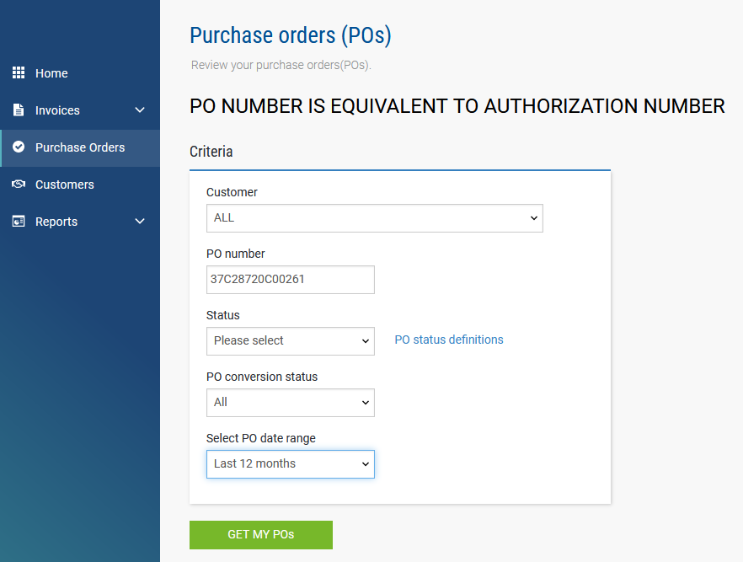
Required fields are indicated with a red asterisk *
Step 1:
1. Confirm you have the Authorization Number email from the Department of Veterans Affairs.
2. Go to Tungsten login page https://portal.tungsten- network.com/Login.aspx?Return Url=%2f
3. Sign in using your user credentials created when you first registered.
4. Once logged into your account, select Purchase Orders from the navigation bar on the left side of the screen.

Step 2:
1 Change “Select PO date range” to Last 12 months.
2. Manually enter your PO/Authorization number from step 1 in the email from the Department of Veterans Affairs into the PO number field.
3. Select "Get My POs".

Step 3:
1. Select the (+) icon next to the specific PO you searched for.
Note: If the PO/Authorization is not found, please contact Tungsten Support.

Step 4:
1. Once the PO/Authorization is open, confirm details for the Veteran.
2. If the information is correct, select “Convert PO”.

Step 5:
1. Enter a unique invoice number.
2. Select one or more lines to invoice against.
3. Update quantity and price information if necessary.
4. Select “Create Invoice”.
5. On the next screen, the information will appear again, if the information is correct, select “Confirm”. If the information is not correct, select “Back” to update the information on the previous screen.

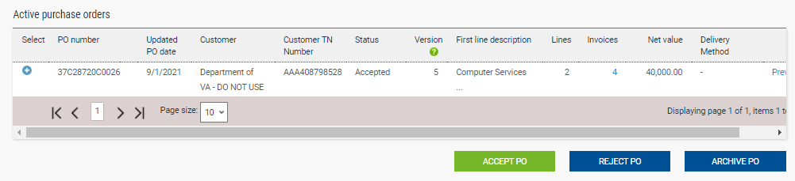
Step 3 – Select Your Authorization/PO Number

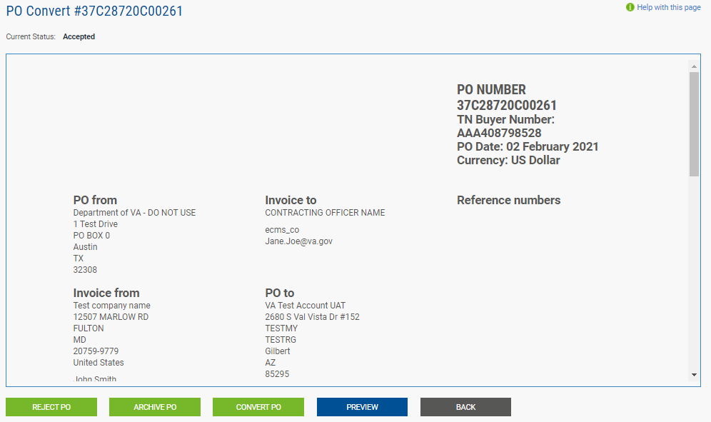
Step 4 – Confirm Authorization Details

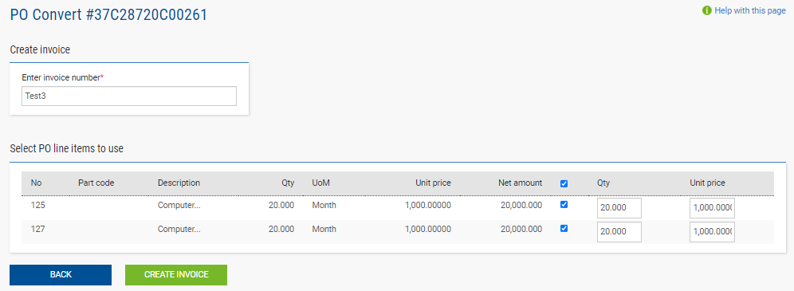
Step 5 – Fill in your contact details

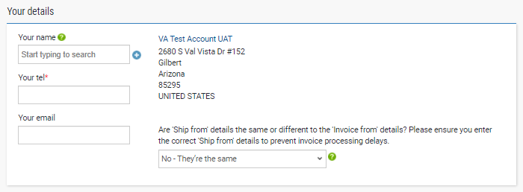
Step 6 – Fill in your contact details

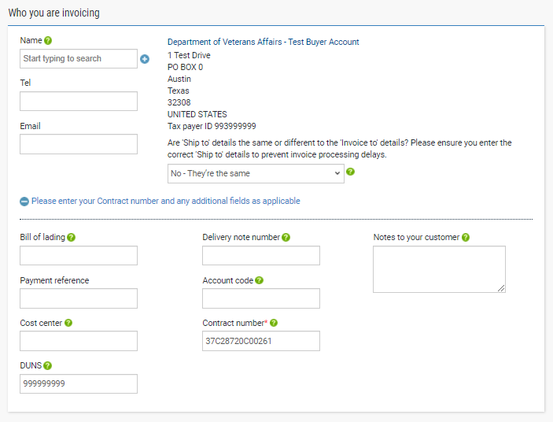
Step 7 – Fill in the contact details of the VA and your contract number

Step 6:
Fill in your contact details.
Note: The contact information should be the person creating the invoice.
1. Fill in your name.
2. * Fill in your telephone number.
3. Fill in your email address.

Step 7:
Fill out the contact information for the Department of Veterans Affairs.
1. Fill in the contact name.
2. Fill in the phone number.
3. Fill in the email address.
Note: This should be your contracting officer or COR.
4. ‘Ship to’ details – If the ‘ship to’ differs from the ‘Invoice to’ details, change the populated answer from, “No – They’re the same” to “Yes- Add a ‘ship from” address” or “N/A – Leave ‘ship from’ blank.”
Note: If you select, “Yes – Add ‘a ship from’ address, additional fields will appear. Please provide an answer for all fields. For the TIN, answer “no”. This field is referring to the VA’s TIN - NOT your supplier TIN.

Step 8:
Attachments are optional unless required by your contracting officer/VA employee certifying your invoice. Claim forms being processed as invoices should always include attachments.
1. Select the “Select and Upload” button to add an attachment.
Note: The only acceptable attachment format is PDF.
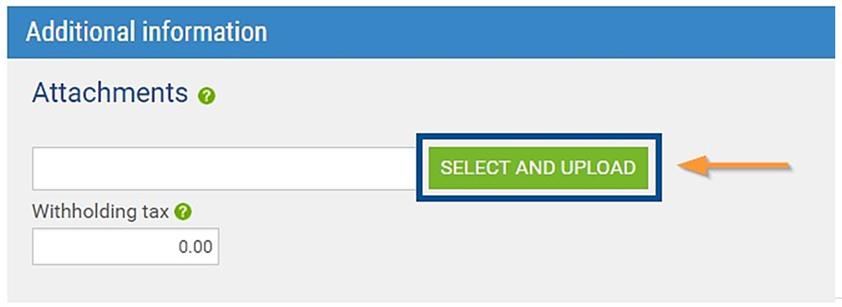
Step 8 – Attachments
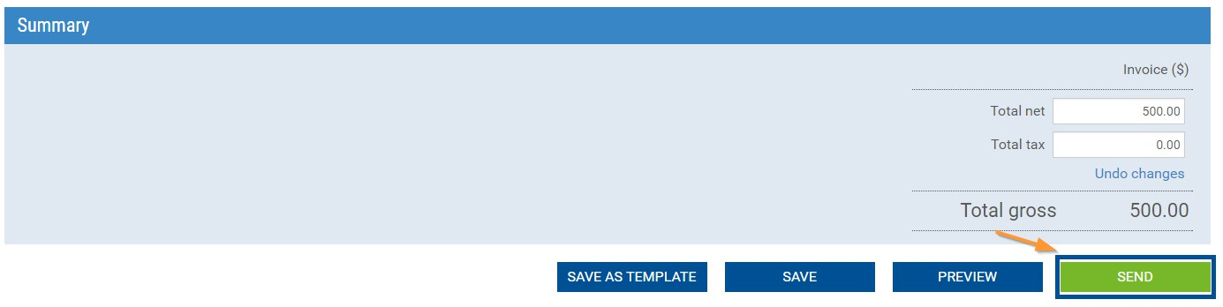
Step 9 – Review your Summary
Step 9:
Please check all fields to ensure everything is accurate before selecting “Send”. Once you have sent the invoice, it cannot be edited or deleted.
Note: After you send your invoice, you will receive a confirmation email. The portal will not display the complete invoice for up to 4 hours after entry. You will be unable to download/print the invoice before you “send”; however, once the portal has updated, you may download the invoice by going to “Reporting,”, “Invoices submitted.”

Additional Information:
An invoice will be delivered to the Department of Veterans Affairs Financial Service Center headquarters within 24 hours after it is accepted by Tungsten Network, at which point it is no longer in Tungsten Network's hands. This is a "delivered" status. Tungsten Network is an electronic invoicing company; it does not process payments or keep track of the payment status. For the status of your payment, and payment method inquiries, you will need to contact the VA Financial Service Center at (877) 353-9791 opt 2, or by visiting the VA Inquiry System at https://www.vis.fsc.va.gov or emailing them at vafsccshd@va.gov.

Frequent Errors:
If the number(s) of the purchase order on your invoice is/are outside the range used by your customer. Please make sure that you are billing the appropriate account, correct the number(s) of the purchase order and resend the invoice.
- Verify that you have entered the purchase order/obligation number correctly as it appears on the purchase order provided by your customer/buyer.
- Verify that the purchase order/obligation number was filled in the “Invoice details” section of the invoice is correct.
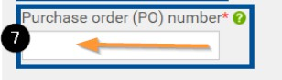
How can I delete or edit an invoice that has been rejected or has not been sent?
To delete or edit
- Click on the Invoicing tab.
- Go to “Saved Invoices” at the bottom of the page.
- Click "edit" or "delete" on the right side.

To correct a rejected invoice
- Click on the Invoicing tab.
- Select "Invoice Status"
- Select in the red section of the status circle of the invoices.
- Select the paper icon under "view details" of the invoice in error.
- Select the navy blue "reactivate Invoice" button.
- Click on the Invoicing tab.
- Go to “Saved Invoices” at the bottom of the page.
- Click "edit" or "delete" in the section of “Saved Invoices”.

Invalid Contract Telephone Number
- Please review step 3 to correct the invoice that has failed.
- Follow the steps “To correct a rejected invoice” to reactivate your invoice. Once reactivated you can edit and resend it to be reprocessed. Please make sure when editing that the contact telephone number field is filled in under the “Your details” section.

